**Servo Pins**

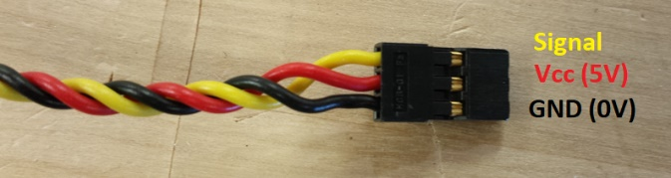

**-Unaltered Servo Control Loop**

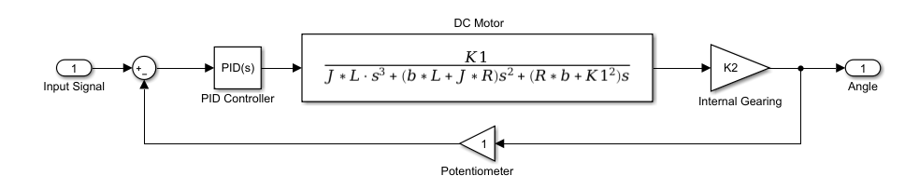

**-Altered Servo Control Loop**

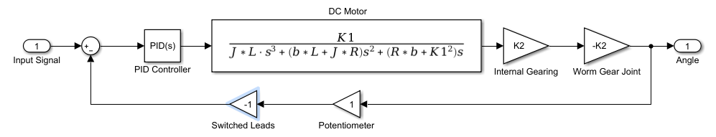

**Arduino Code**

